WELCOME TO EZYTRX TEAM
How to Start and Grow Your Own Profitable Online Business Step By Step!
DAY1 – Getting Started and Actual Conversation with EZYTRX Prospect. Page1.
OUR MISSION: Page 17.
DAY2 – 5 Simple and Easy Steps to Get Started with EZYTRX Team. Page 18.

DAY1 – Getting Started and Actual Conversation with EZYTRX Prospect.
[5:31 AM, 10/21/2020] +92 300 7507562: 1. Did you read the Fast Start Guide and watch the videos there?
https://ezytrx.com/fast-start-guide
Your Answer: Yes I did!
2. Did you Download the Tronlink smart wallet?
A. Tronlink Wallet Chrome Browser Extension: https://chrome.google.com/webstore/detail/tronlink/ibnejdfjmmkpcnlpebklmnkoeoihofec
and or
B. Mobile Wallet: https://tronlink.org
Yes I did!
3. Cool. Did you buy and transfer cryptocurrency TRX to your Tronlink wallet?
4. After that, here is your join link: see below
5. Have you registered paid for your first slot of 1000 TRX in the EZYTRX smart contract?
Your Answer: Yes I Have!
My number is: [ xxxx ]
I will speak with you soon and work with you.
Tutorman
*Please Go and Read the 'Fast Start Guide' If You Have Any Problems!
[5:33 AM, 10/21/2020] Tutorman: Hello Nayar, how are you?
[5:33 AM, 10/21/2020] +92 300 7507562: Fine
[5:34 AM, 10/21/2020] Tutorman: Awesome
[5:34 AM, 10/21/2020] Tutorman: Let me ask you a question? Are you using mobile to build your business or laptop?
[5:35 AM, 10/21/2020] Tutorman: If you have any questions about how to build your EZYTRX business, I'm here to help you!
[6:03 AM, 10/21/2020] +92 300 7507562: I want to join for non working how can you help me
[6:05 AM, 10/21/2020] Tutorman: 1. when you have your tronlink wallet loaded with tron, let me know and i will give you the affiliate link to join
[6:05 AM, 10/21/2020] Tutorman: 2. I will give you the affiliate link to join
[6:05 AM, 10/21/2020] Tutorman: 3. then after you sign up, you give me your affiliate link
[6:06 AM, 10/21/2020] Tutorman: 4. You will receive 55% cash back (TRX), when i sign up the next person directly under you
[6:06 AM, 10/21/2020] Tutorman: i build that powerline 10+ people deep so that you benefit from the 88572 members in your future downline
[6:07 AM, 10/21/2020] +92 300 7507562: It's guaranteed you will give me direct refrel
[6:07 AM, 10/21/2020] Tutorman: it's possible that you will get 100% cash back or more
[6:07 AM, 10/21/2020] Tutorman: Yes, i personally guarantee 1X direct referral and the powerline
[6:07 AM, 10/21/2020] Tutorman: nobody else does this
[6:08 AM, 10/21/2020] +92 300 7507562: Now your team no
[6:08 AM, 10/21/2020] Tutorman: so then you build your first referral and help them
[6:08 AM, 10/21/2020] Tutorman: i have more than 100 members, but that is not important
[6:08 AM, 10/21/2020] Tutorman: i'm here to help you
[6:09 AM, 10/21/2020] +92 300 7507562: Send me your link
[6:09 AM, 10/21/2020] Tutorman: also my website is #1 recruiting website, and after you had upgraded, i will give you a page on the site
[6:09 AM, 10/21/2020] Tutorman: so that you can benefit from that too
[6:10 AM, 10/21/2020] Tutorman: there are also other secret team benefits that i will explain after you had upgraded
[6:10 AM, 10/21/2020] +92 300 7507562: Ok
[6:10 AM, 10/21/2020] +92 300 7507562: That's good
[6:10 AM, 10/21/2020] Tutorman: i can also do presentations for your personals and team of course
[6:10 AM, 10/21/2020] Tutorman: using Zoom etc
[6:10 AM, 10/21/2020] Tutorman: can you show me how much tron you have in your wallet?
[6:11 AM, 10/21/2020] Tutorman: do you have 1001 tron in your wallet?
[6:11 AM, 10/21/2020] +92 300 7507562: At that time only 10 tomorrow I will arrange
[6:12 AM, 10/21/2020] Tutorman: ok, great. I will give you 24 hours from now to fund/load your wallet with tron
[6:12 AM, 10/21/2020] Tutorman: i am here to help you start and grow your business
[6:13 AM, 10/21/2020] +92 300 7507562: Actually I connect with many people for ezytrx but I want tou get maximum support
[6:13 AM, 10/21/2020] Tutorman: https://ezytrx.com/buy-tron-trx/
[6:13 AM, 10/21/2020] Tutorman: I will help you step by step
[6:14 AM, 10/21/2020] Tutorman: i have autopilot recruiting system that i will share with my downline
[6:15 AM, 10/21/2020] Tutorman: the key thing is to help downline make money... if downline business is growing, then your business is growing
[6:15 AM, 10/21/2020] Tutorman: many people promise, but few people get results
[6:16 AM, 10/21/2020] Tutorman: my promise at this stage is you get immediate 55% cash back from the first one I put under you
[6:17 AM, 10/21/2020] Tutorman: good luck, I'm Leo
[6:17 AM, 10/21/2020] +92 300 7507562: Can you send me your real pic plz
[6:18 AM, 10/21/2020] Tutorman: this is my website: https://ezytrx.com
[6:18 AM, 10/21/2020] Tutorman: my real picture is there, and my videos are there
[6:19 AM, 10/21/2020] Tutorman: look under 'the tutorman story'
[6:19 AM, 10/21/2020] Tutorman: https://ezytrx.com/the-tutorman-story/
[6:25 AM, 10/21/2020] +92 300 7507562: OK send me your I'd please
[6:26 AM, 10/21/2020] Tutorman: please show me 1000 TRX in your tron wallet
[6:27 AM, 10/21/2020] +92 300 7507562: Tomorrow I will arrange and send you screen shot
[6:27 AM, 10/21/2020] Tutorman: ok, great
[6:29 AM, 10/21/2020] +92 300 7507562: Please remember your commitment
[6:30 AM, 10/21/2020] Tutorman: don't worry, you will see
[6:30 AM, 10/21/2020] +92 300 7507562: OK thanks
[6:32 AM, 10/21/2020] Tutorman: Which city are you in?
[6:32 AM, 10/21/2020] Tutorman: are you in Karachi?
[6:32 AM, 10/21/2020] Tutorman: (i'm in australia, Melbourne)
[6:36 AM, 10/21/2020] +92 300 7507562: Islamabad
[6:36 AM, 10/21/2020] Tutorman: ok thanks
[6:37 AM, 10/21/2020] +92 300 7507562: How much scope of ezytrx in Australia
[6:38 AM, 10/21/2020] Tutorman: this business is global. i use online marketing and not face to face to build this business. there are 5 billion people we can sponsor
[6:39 AM, 10/21/2020] +92 300 7507562: OK good thanks
[6:39 AM, 10/21/2020] Tutorman: this business i believe will never be shut down
[6:39 AM, 10/21/2020] Tutorman: it will be evergreen and it will never saturate
[6:39 AM, 10/21/2020] +92 300 7507562: I want to earn maximum trx
[6:40 AM, 10/21/2020] Tutorman: so i build a long term business, i invest in websites and hosting and i create youtube channels... soon i will do paid advertising to sponsor the masses
[6:41 AM, 10/21/2020] +92 300 7507562: Great plz guide me about all these things
[6:41 AM, 10/21/2020] Tutorman: sure
[5:15 PM, 10/21/2020] Tutorman: Your downline is waiting for you
[5:17 PM, 10/21/2020] Tutorman: Do not wait because your future downline will become your sponsor
[5:27 PM, 10/21/2020] Tutorman: Getting Started Notes:
Getting Started:
1. Android: https://play.google.com/store/apps/details?id=com.tronlinkpro.wallet
iPhone: https://itunes.apple.com/us/app/tronlink/id1453530188
Personal Computer, Chrome Browser Extension Wallet: https://chrome.google.com/webstore/detail/tronlink/ibnejdfjmmkpcnlpebklmnkoeoihofec
2. When you have your Tronlink mobile wallet loaded with 1001 Tron (TRX), let me know and i will give you the affiliate link to join.
- You must contact me, and I will give you the affiliate link to join.
3. Then after you sign up, you give me your affiliate link.
4. You will receive 55%+ cash back (TRX) from my efforts, when i sign up the next person directly under you.
5. I build that powerline 10+ people deep so that you benefit from the 88572 members…
[5:48 PM, 10/21/2020] Tutorman: please use tronlink.org wallet
[5:48 PM, 10/21/2020] Tutorman: you are using a tron wallet
[5:48 PM, 10/21/2020] Tutorman: and you will need 1001 TRX
[5:48 PM, 10/21/2020] Tutorman: do you use android or iphone?
[5:48 PM, 10/21/2020] +92 300 7507562: Ok
[5:49 PM, 10/21/2020] +92 300 7507562: Android
[5:49 PM, 10/21/2020] Tutorman: ok
[5:49 PM, 10/21/2020] Tutorman: 1. Android: https://play.google.com/store/apps/details?id=com.tronlinkpro.wallet
[5:49 PM, 10/21/2020] Tutorman: this is the wallet i recommend... we try and keep the procedure standard for all members
[5:50 PM, 10/21/2020] +92 300 7507562: Plz wait for me I have sent local money to exchanger he will send me trx at 5 pm plz plz plz wait for me
[5:50 PM, 10/21/2020] Tutorman: great!
[5:51 PM, 10/21/2020] +92 300 7507562: Ok
[6:08 PM, 10/21/2020] +92 300 7507562: I have downloaded
[6:17 PM, 10/21/2020] Tutorman: ok great
[6:34 PM, 10/21/2020] +92 300 7507562: I have received 324 trx wait for remaining actually here is difficulty to arrange crypto thanks wait for me
[7:00 PM, 10/21/2020] Tutorman: you need at least 1001 to open the first slot in the smart contract
[7:50 PM, 10/21/2020] +92 300 7507562: How many trx I can earn from this System in one month can you guess?
[10:45 PM, 10/21/2020] Tutorman: From each personally sponsored downline, you will receive 55% commission immediately. Sponsor 2X and you are in profit.
[10:46 PM, 10/21/2020] Tutorman: the key is to empower the downline to build the business. and this is my strategy because we can earn more from team effort if the team is builders. If they are not then we earn more from personal referral.
[10:47 PM, 10/21/2020] Tutorman: the income you can earn is unlimited
[10:47 PM, 10/21/2020] Tutorman: after 10x you will be prompted to upgrade to the next slot
[10:34 PM, 10/21/2020] +92 300 7507562: Plz send me link for joining
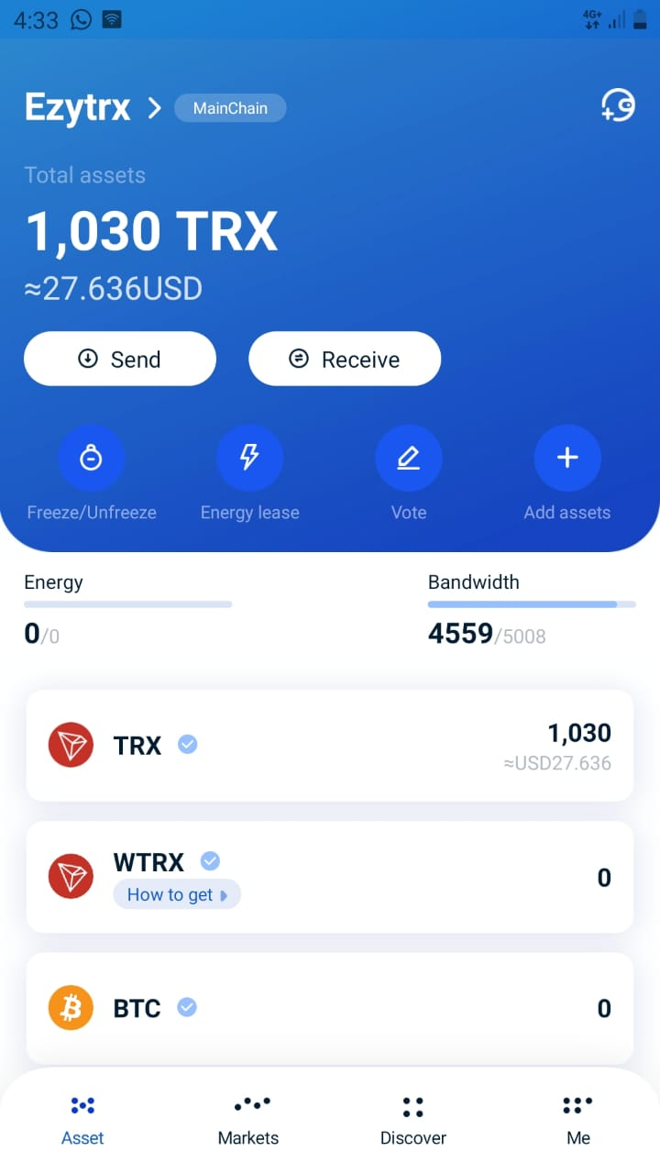
[10:49 PM, 10/21/2020] Tutorman: ok well done
[10:52 PM, 10/21/2020] Tutorman: please watch this video first
[10:52 PM, 10/21/2020] Tutorman: https://www.youtube.com/watch?v=b0of00Xeieo
[10:53 PM, 10/21/2020] Tutorman: Then enter this URL into your Tronlink wallet browser
[10:53 PM, 10/21/2020] Tutorman: [deleted] Please see link below.
[10:54 PM, 10/21/2020] Tutorman: after that, please give me your affiliate link, and I will use it for the next member to join. When that member joins, you will receive 55% cash back!
[10:55 PM, 10/21/2020] Tutorman: and you will continue to receive team commissions, because i will drive that position down
[10:59 PM, 10/21/2020] +92 300 7507562: Thanks a lot you are great
[11:07 PM, 10/21/2020] +92 300 7507562: This link not browsing in tronlink browser
[11:08 PM, 10/21/2020] Tutorman: you need to refresh your wallet and try again
[11:08 PM, 10/21/2020] Tutorman: give it time to engage the smart contract
[11:09 PM, 10/21/2020] Tutorman: also if it doesn't work the second time you try, then you can go into your google chrome browser app, and enter this URL:
https://exytrx.com/link [ the current link to join is found here ]
[11:10 PM, 10/21/2020] Tutorman: you need to click the little right arrow =>
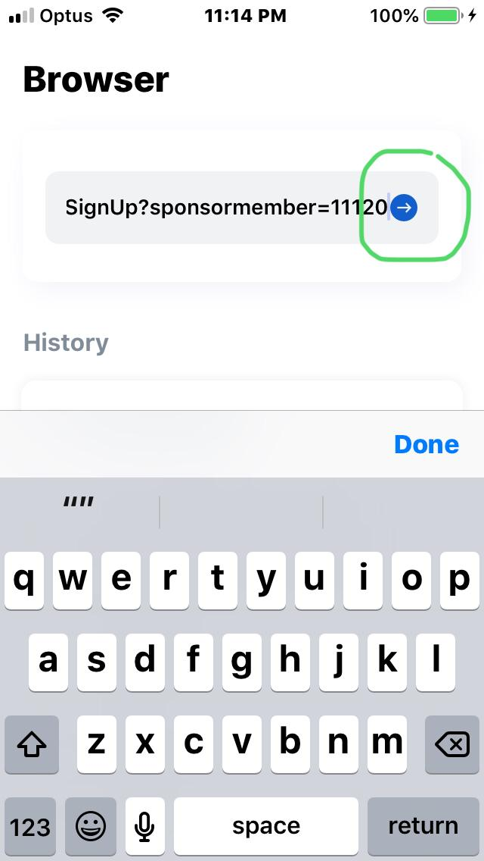
[11:12 PM, 10/21/2020] +92 300 7507562: Here is not any arrow
[11:15 PM, 10/21/2020] Tutorman: click done, or enter
[11:16 PM, 10/21/2020] Tutorman: i use Apple iOS version and there is a little arrow
[11:16 PM, 10/21/2020] +92 300 7507562: Actually tronlink browser not working
[11:17 PM, 10/21/2020] +92 300 7507562: Can I join through tron wallet
[11:18 PM, 10/21/2020] Tutorman: some people use tron wallet, but i do not because i find tronlink the most simple..
[11:18 PM, 10/21/2020] Tutorman: just a moment
[11:19 PM, 10/21/2020] +92 300 7507562: In tron wallet has open
[11:20 PM, 10/21/2020] Tutorman: i would recommend tokenpocket as your second choice
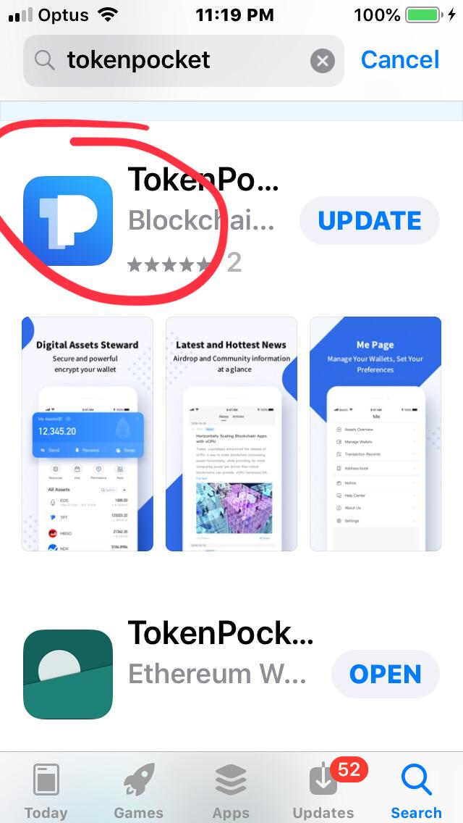
[11:21 PM, 10/21/2020] Tutorman: because there are many happy users using this one on Android!
[11:22 PM, 10/21/2020] Tutorman: of course you can try tron wallet, but i do not recommend it... i tell the whole team to use Tronlink and use the same system, not confuse members by using all different wallets
[11:24 PM, 10/21/2020] Tutorman: token pocket pro is my second choice.
[11:26 PM, 10/21/2020] Tutorman: if you go into the google chrome browser app, and enter the join link:
You will find the updated link here:
https://ezytrx.com/link
[11:26 PM, 10/21/2020] Tutorman: that should work too
[11:28 PM, 10/21/2020] Tutorman: take screen shots of your successful registration
[12:15 AM, 10/22/2020] +92 300 7507562: What do now?
[12:15 AM, 10/22/2020] Tutorman: wait on that page
[12:16 AM, 10/22/2020] Tutorman: wait for the transaction to confirm...
[12:16 AM, 10/22/2020] +92 300 7507562: OK waiting
[12:16 AM, 10/22/2020] Tutorman: which wallet are you using?
[12:17 AM, 10/22/2020] +92 300 7507562: Tronlink Pro in laptop chrome extension
[12:17 AM, 10/22/2020] +92 300 7507562: Same page
[12:17 AM, 10/22/2020] +92 300 7507562: What do
[12:17 AM, 10/22/2020] Tutorman: ok, good
[12:18 AM, 10/22/2020] Tutorman: you need to scroll down and press the confirm button on the
[12:18 AM, 10/22/2020] +92 300 7507562: Here is not confirm button
[12:19 AM, 10/22/2020] +92 300 7507562: How I search my id
[12:19 AM, 10/22/2020] +92 300 7507562: ?
[12:20 AM, 10/22/2020] Tutorman: with the chrome extension wallet, there is an accept button at the bottom of your wallet
[12:20 AM, 10/22/2020] Tutorman: so open your wallet in the chrome extension
[12:20 AM, 10/22/2020] Tutorman: scroll down and there is an accept button
[12:20 AM, 10/22/2020] Tutorman: https://www.youtube.com/watch?v=nx2UZQesXnw
[12:21 AM, 10/22/2020] +92 300 7507562: Trx has gone
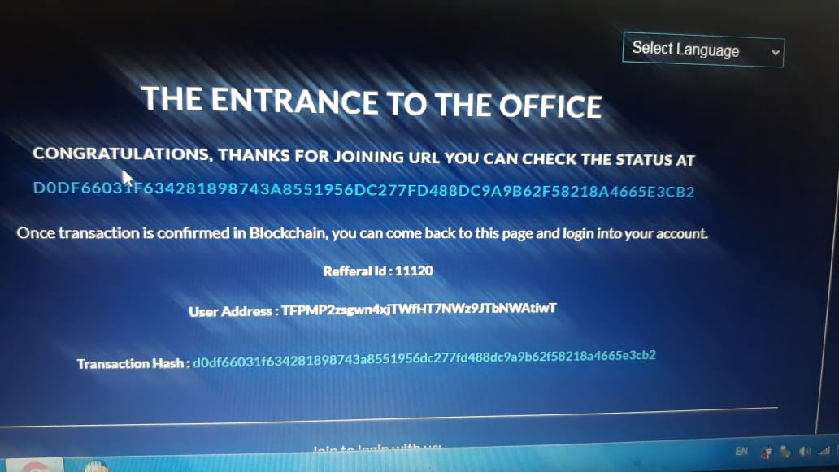
[12:21 AM, 10/22/2020] Tutorman: ok
[12:22 AM, 10/22/2020] Tutorman: got it
[12:22 AM, 10/22/2020] Tutorman: 15109
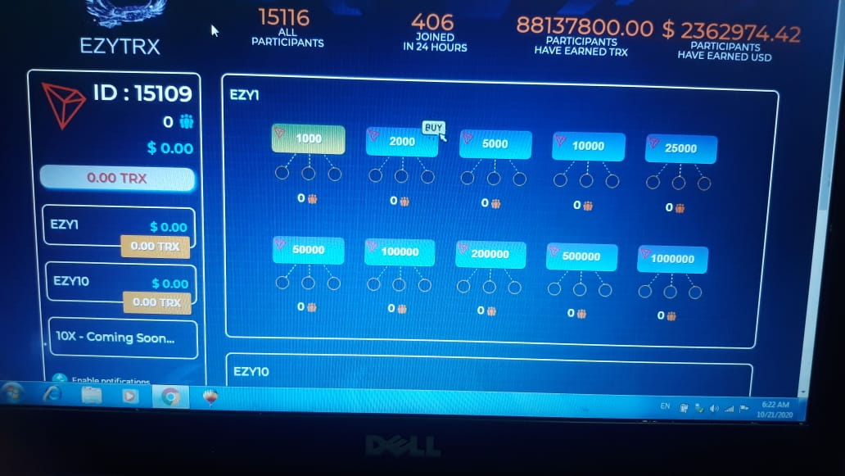
[12:22 AM, 10/22/2020] +92 300 7507562: This my ID?
[12:23 AM, 10/22/2020] Tutorman: there are 3 ways to log in.
1. just view or authorize and it should remember you the first time;
2. add your number: 15109;
3. add your wallet address and then press view or authorize.
[12:23 AM, 10/22/2020] Tutorman: the url to log in is ezytrx.io
[12:24 AM, 10/22/2020] +92 300 7507562: OK I am sending you my link
[12:25 AM, 10/22/2020] Tutorman: I prefer to use the iphone ios tronlink wallet, it works well; for android members tell me the tokenpocket wallet is good; and chrome extension works well on personal computer
[12:25 AM, 10/22/2020] Tutorman: i know your link already, but thanks
[12:25 AM, 10/22/2020] +92 300 7507562: Ok
[12:25 AM, 10/22/2020] Tutorman: please give me your email address
[12:26 AM, 10/22/2020] +92 300 7507562: I have yahoo addredd
[12:26 AM, 10/22/2020] Tutorman: great
[12:26 AM, 10/22/2020] Tutorman: my email is ezytrx@gmail.com
[12:27 AM, 10/22/2020] Tutorman: is your name Nayyar Sharif?
[12:27 AM, 10/22/2020] +92 300 7507562: yes
[12:27 AM, 10/22/2020] Tutorman: ok
[12:27 AM, 10/22/2020] +92 300 7507562: Nayyar_sharif2000@yahoo.com
[12:27 AM, 10/22/2020] +92 300 7507562: plz further guide me and help me in future
[12:28 AM, 10/22/2020] +92 300 7507562: i will be thankful to you
[12:28 AM, 10/22/2020] Tutorman: 1. Please join this Telegram group:
https://t.me/ezytrxofficial
[12:28 AM, 10/22/2020] Tutorman: this is the main group
[12:28 AM, 10/22/2020] +92 300 7507562: and please guide me how can i grow my business with your support
[12:28 AM, 10/22/2020] +92 300 7507562: ok i am joining
[12:29 AM, 10/22/2020] Tutorman: you can get the latest information there, especially when you join the live webinars every day
[12:30 AM, 10/22/2020] Tutorman: weekly webinars on Sunday night have latest news
[12:30 AM, 10/22/2020] +92 300 7507562: you conduct any zoom meetings?
[12:30 AM, 10/22/2020] Tutorman: I conduct zoom meetings; and company conducts zoom meetings...
[12:30 AM, 10/22/2020] +92 300 7507562: please when you got any member from pakistan give him my no and contacted with me please
[12:30 AM, 10/22/2020] +92 300 7507562: in india is very good working on ezytrx
[12:31 AM, 10/22/2020] Tutorman: zoom meeting schedule is inside the telegram group. It's good to send a visitor there
[12:31 AM, 10/22/2020] +92 300 7507562: if you like kindly give me direct referals from there thanks
[12:31 AM, 10/22/2020] Tutorman: ok, no problem (pakistan member, can go with you)
[12:32 AM, 10/22/2020] +92 300 7507562: I will send back trx in your wallet from my earning thanks
[12:32 AM, 10/22/2020] +92 300 7507562: thanks a lot
[12:32 AM, 10/22/2020] Tutorman: if you want me to do a meeting for you, tell me the time and i can do it
[12:32 AM, 10/22/2020] +92 300 7507562: ok
[12:34 AM, 10/22/2020] Tutorman: EZYTRX ENGLISH Presentation 🎯
☄️☄️
Monday ,Wednesday, Saturday
@8:00 PM UK
👇👇
https://us02web.zoom.us/j/81180509268
PASSCODE: 123 👈👈
[12:35 AM, 10/22/2020] Tutorman: in 5.5 hours there is a presentation from the EZYTRX team
[12:35 AM, 10/22/2020] Tutorman: New York time 15:00
[12:36 AM, 10/22/2020] Tutorman: London 8:00pm
[12:36 AM, 10/22/2020] Tutorman: it's 6am for me, in Australia
[12:36 AM, 10/22/2020] Tutorman: Karla usually does the presentation
[12:37 AM, 10/22/2020] Tutorman: my upline is there to co-ordinate the meeting
[12:37 AM, 10/22/2020] Tutorman: they have meetings in Hindi/Urdu too
[12:37 AM, 10/22/2020] Tutorman: every other day, so tomorrow, is Hindi
[12:38 AM, 10/22/2020] +92 300 7507562: Realy
[12:38 AM, 10/22/2020] Tutorman: yes
[12:38 AM, 10/22/2020] Tutorman: the information is in the telegram group
[12:38 AM, 10/22/2020] +92 300 7507562: Can you send me urdu meeting link and Pakistani time?
[12:38 AM, 10/22/2020] Tutorman: please go to to the telegram group for details
[12:39 AM, 10/22/2020] Tutorman: https://t.me/ezytrxofficial/411
[12:42 AM, 10/22/2020] Tutorman: when you sponsor someone you will get this commission
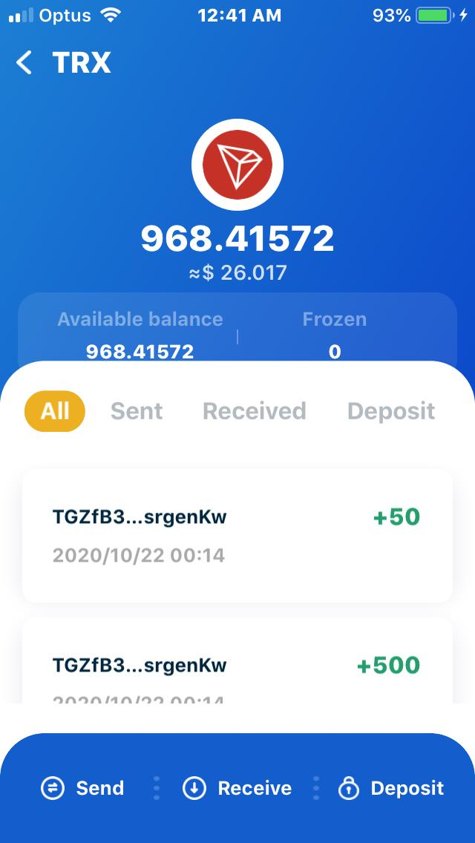
[12:42 AM, 10/22/2020] Tutorman: 55% x 1000 trx immediately
[12:43 AM, 10/22/2020] Tutorman: = 550 trx
[12:43 AM, 10/22/2020] +92 300 7507562: OK nice
[12:44 AM, 10/22/2020] Tutorman: plus you will receive other commissions from the efforts of your downline and upline
[12:44 AM, 10/22/2020] +92 300 7507562: Can you tell me total no of your team along with upline
[12:44 AM, 10/22/2020] Tutorman: 15109
[12:45 AM, 10/22/2020] +92 300 7507562: Ok
[12:45 AM, 10/22/2020] +92 300 7507562: All team under you
[12:45 AM, 10/22/2020] +92 300 7507562: ?
[12:45 AM, 10/22/2020] Tutorman: I have 200, but i am still testing.
[12:46 AM, 10/22/2020] Tutorman: when my marketing system is ready, i will start to promote
[12:46 AM, 10/22/2020] +92 300 7507562: Testing means?
[12:46 AM, 10/22/2020] Tutorman: i do not promote the business
[12:46 AM, 10/22/2020] Tutorman: my downline comes to me and asks me to join like you
[12:46 AM, 10/22/2020] Tutorman: how did you find me?
[12:46 AM, 10/22/2020] +92 300 7507562: Very nice
[12:47 AM, 10/22/2020] +92 300 7507562: Your are really good, nice
[12:47 AM, 10/22/2020] +92 300 7507562: I whole day wait to joining with you
[12:48 AM, 10/22/2020] +92 300 7507562: I WAS also facing money problem but I have to succeed join under you thanks
[12:48 AM, 10/22/2020] Tutorman: Can you tell me how did you find me online?
[12:49 AM, 10/22/2020] +92 300 7507562: Amazing
[12:49 AM, 10/22/2020] +92 300 7507562: And your site is ranking on first page its amazing
[12:50 AM, 10/22/2020] Tutorman: ok, but how did you get interested in EZYTRX?
[12:50 AM, 10/22/2020] Tutorman: you must have seen it somewhere?
[12:51 AM, 10/22/2020] +92 300 7507562: Actually I see one post of ezytrx on fb
[12:51 AM, 10/22/2020] Tutorman: ok, i see
[12:51 AM, 10/22/2020] Tutorman: https://www.youtube.com/watch?v=2EmXhC7osdo
[12:51 AM, 10/22/2020] Tutorman: the developer and team is creating a marketing system for members... it should be ready in a week or 2
[12:52 AM, 10/22/2020] Tutorman: The developer of the Smart Contract is Nichlaus D'Cruz from Singapore.
[12:52 AM, 10/22/2020] +92 300 7507562: When I search in Google your site was at top I click it read it and join your what app then you give me hope and satisfy me in a good way
[12:52 AM, 10/22/2020] +92 300 7507562: Ok
[12:53 AM, 10/22/2020] +92 300 7507562: I will study about this and will work with it
[12:53 AM, 10/22/2020] Tutorman: when i heard about the future launching of EZYTRX, i went and bought the domain because this smart contract will have a long life, so i prepared for this business
[12:54 AM, 10/22/2020] +92 300 7507562: How it will be beneficial
[12:54 AM, 10/22/2020] Tutorman: it's beneficial because its much easier to track people
[12:54 AM, 10/22/2020] Tutorman: and it will have some automations
[12:54 AM, 10/22/2020] +92 300 7507562: Ok
[12:54 AM, 10/22/2020] +92 300 7507562: Ok
[12:54 AM, 10/22/2020] Tutorman: it has all important data inside
If you are reading this transcript, and want to join the powerline, you can find the Join Link here: Ezytrx.com/link
Thank You!
Tutorman
Team Leader
P.s The next member to join the powerline should join under the link listed here:
Ezytrx.com/link

Ezytrx Team Powerline Registration Link
Welcome to the EZYTRX Team.
Our Mission:
a. Our Mission is to empower every member with the tools and resources to build this evergreen business quickly and easily.
b. The Powerline serves as the security for every member to receive 55%+ Cash Back instantly on their investment for the first position of 1000 TRX.
c. 550+ TRX is guaranteed for you when you join with the link below.
d. Your success and profit is guaranteed by Tutorman when you join this powerline!
The Current Powerline Join Link:
Ezytrx.com/link
ID = please see the link above for the current ID number.
You will get full support from me when you join with this powerline link.
Tutorman is willing to give up his personal profit in EZY1 program to help you you start and grow your business to the highest level.
It's all about the teamwork in EZY10 program.
Click the Button Below to get started now!
I Guarantee Your Success:
When You have signed up, with a 1000 TRX position, please contact Tutorman and give him your affiliate link so that he can replace the previous link, with your link and ID number!
If you have any questions, they will be answered on the website: https://ezytrx.com
If you want the latest link to join go to: https://ezytrx.com/link
To your success,
Tutorman
Helping people to help themselves and freeing the world.
*See Training Below.

DAY2 – 5 Simple and Easy Steps to Get Started with EZYTRX Team.
https://ezytrx.com/get-started-now/ Select Your Method
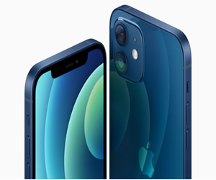
Example: Sign Up Using iPhone. https://ezytrx.com/buy-tron-trx/
Step 1 – Buy $100 or More of Tron TRX
Watch Video: https://www.youtube.com/watch?v=HTCGblxEaVg
Step 2 – Get a Tronlink.org Mobile Wallet
Watch Video: https://www.youtube.com/watch?v=8o2fzw6k3L4
Step 3 – Transfer TRX from Exchange to Tronlink Wallet
Watch Video: https://www.youtube.com/watch?v=Q2AsVXQSsUs
Step 4 – EZYTRX Registration with Tronlink Mobile Wallet
Watch Video: https://www.youtube.com/watch?v=b0of00Xeieo
Step 5 – EZYTRX Upgrade Step By Step!
Watch Video: https://www.youtube.com/watch?v=5F2HGzvz-go
* Join the EZYTRX Team
The Link to Join The EZYTRX Team Powerline is here: https://ezytrx.com/link
** Facebook Ezytrx Team Page: (like the page)
https://www.facebook.com/ezytrx
*** Youtube Channel: (subscribe to the channel)
https://www.youtube.com/c/EzyTrxLegacy?sub_confirmation=1
If you are using a Personal Computer to Sign Up go to:
https://ezytrx.com/ezytrx-fast-start-guide/
Thank You!
Tutorman
Team Leader
P.s The next member to join the powerline should join under the link listed here:
Ezytrx.com/link

